AI AUTOMATION
INTERNSHIP
DAY 03 — LEAD MANAGEMENT API
Postman • n8n Webhooks • Google Sheets

Student Name | Muhammad Moosa Bin Shoaib
Repository | AI-Automation-Internship
Module | Lead Management API
Day | 03

A practical implementation of a webhook-based CRUD API,
using n8n as the automation layer and Google Sheets as the data store.

1. Executive Summary
Day 03 focused on building and testing a simple Lead Management API for the MATalogics internship. The implementation uses n8n Webhooks as API endpoints, Google Sheets for persistent lead storage, and Postman for API testing. The completed system supports the four core CRUD-style lead operations specified in the task: creating, retrieving, updating, and deleting leads.

2. Project Links
Resource | Link
GitHub Repository | https://github.com/moosacannotcode/AI-Automation-Internship/tree/main/Day-03
Open Source Repository | https://github.com/moosacannotcode/n8n

3. APIs Implemented
The Postman collection was organized around four API endpoints. Each endpoint maps to an n8n webhook and performs an operation against the Google Sheets lead database.
Method | Endpoint | Purpose | Data Operation
POST | /create-lead | Create a new lead | Append a row
GET | /get-leads | Retrieve all leads | Read rows
PUT | /update-lead | Update an existing lead | Find and update row
DELETE | /delete-lead | Delete an existing lead | Find and delete row

4. Workflow Overview
All four API operations were developed within a single n8n workflow, as required by the task. Each webhook receives the corresponding HTTP request, performs the required Google Sheets operation, and returns an HTTP response through a Respond to Webhook node.

Create Lead
POST webhook → Edit Fields → Google Sheets (Append Row) → Respond to Webhook

Get All Leads
GET webhook → Google Sheets (Get Row(s)) → Respond to Webhook

Update Lead
PUT webhook → Google Sheets (Update Row) → Respond to Webhook

Delete Lead
DELETE webhook → Google Sheets (Get/Find Row) → Google Sheets (Delete Row) → Respond to Webhook
The workflow screenshot below shows the four webhook branches and their connected Google Sheets and response nodes.
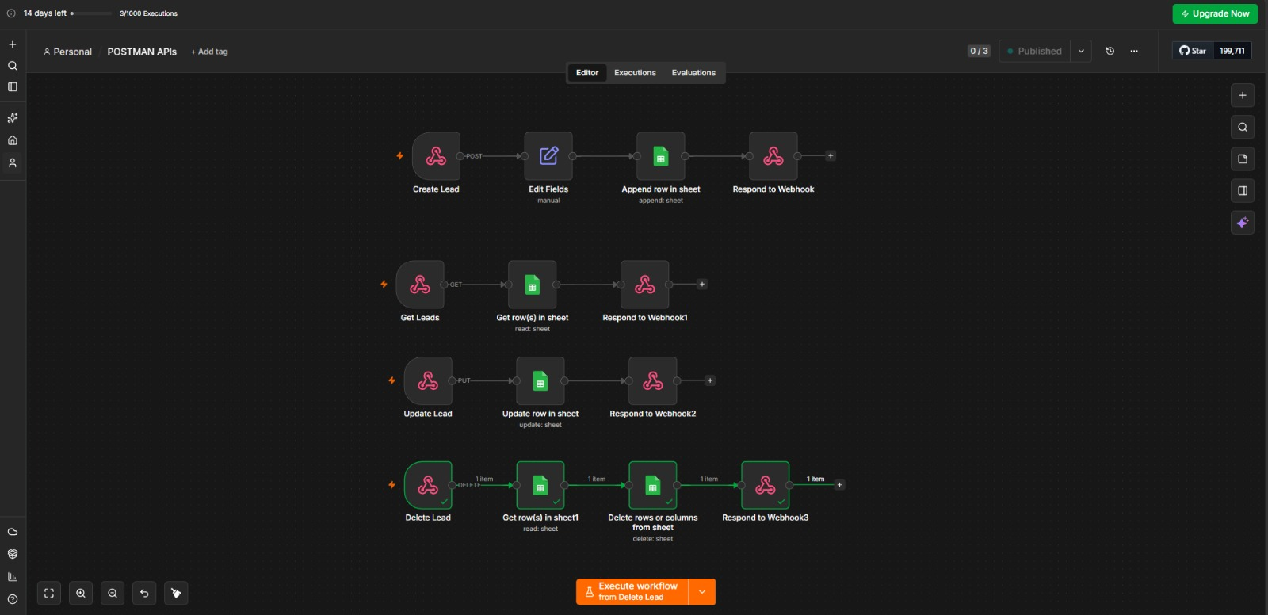
Figure 1. MATalogics Lead Management API — n8n workflow overview.

5. Data Storage — Google Sheets
Lead records are stored in the Google Sheet used by the workflow. The implemented structure contains the fields Name, Email, Phone, Company, Interest, and Created At. The Google Sheets nodes provide the persistent data layer for the API operations.

6. Postman Testing
Postman was used to organize and test the API endpoints. The collection includes the four required HTTP methods, a base URL variable, JSON request bodies where required, and appropriate request configuration. The API responses were checked during testing to verify successful execution.

7. Learning Outcomes
- Learned how to expose n8n workflows as API endpoints using Webhook nodes.
- Practiced passing JSON request bodies from Postman into an n8n workflow.
- Learned how to map webhook data into Google Sheets operations for persistent storage.
- Understood the role of Respond to Webhook in returning API responses to the client.
- Practiced testing API endpoints independently in Postman and interpreting HTTP responses.
- Gained experience organizing multiple related API operations inside a single n8n workflow.
- Improved understanding of how no-code/low-code automation platforms can function as lightweight backend API layers.

8. Conclusion
The Day 03 implementation demonstrates a complete lead-management API pattern using n8n, Postman, and Google Sheets. The four endpoints provide the required create, read, update, and delete capabilities while keeping the workflow centralized in n8n. This exercise provided practical experience in webhook-based API design, request testing, data mapping, and response handling.

MATalogics AI Automation Internship • Day 03

